Curriculum Vitae
1. Personal Information:
Name: John Huang 黃約翰
Born: October 16, 1972; Tainan, Taiwan.
Current position: Attending Staff, Division of Colorectal Surgery, Department of Surgery, National Taiwan University Hospital.
Telephone: +886-2-2312-3456 ext. 65904
E-mail: docjohn@ntuh.gov.tw

2. Education:
1991/09--1998/06: M.D., National Taiwan University, School of Medicine
2004/09-- : Ph.D. candidate, National Taiwan University, Institute of Clinical Medicine

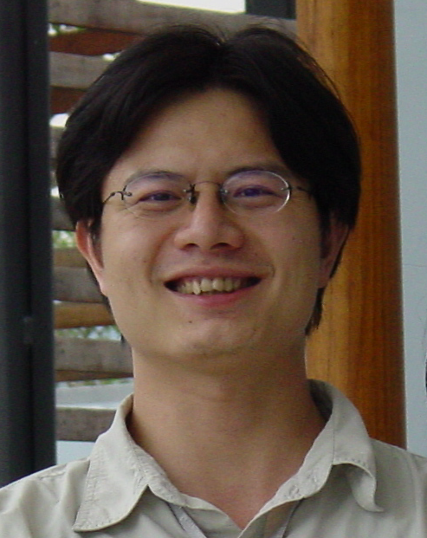

3. Professional career:
2006/07--present Attending Staff, Division of Colorectal Surgery, Department of Surgery, National Taiwan University Hospitals
2004/07--2006/06 Attending Staff, Division of Colorectal Surgery, Department of Surgery, YunLin Branch, National Taiwan University Hospital
2003/07--2004/06 Fellow in colorectal surgery, Department of Surgery, National Taiwan University Hospital
1999/07--2003/07 Resident and Chief Assistant, Department of Surgery, National Taiwan University Hospital

4. Professional memberships:
2003- Association of Surgery, ROC.
2003- Taiwan Surgical Society of Gastroenterology.
2003- Chinese Association for Endoscopic Surgery
2004- Association of Colon and Rectal Surgeons, ROC.

5. Certificate:
2003: Advanced Trauma Life Support course
2004: Good Clinical Practice-Professional Workshop
6. Principal areas of interest:
Anorectal pathophysiology
Laparoscopy Colorectal Surgery
Carcinogenesis of colorectal cancer

7. Publications
1. Sedatives and neuromuscular blockade in neurosurgical intensive care: Huang SJ, Huang J, Kao MC. Taiwan Crit. Care Med. 2001;3:90-102

2. Vancomycin Resistant Enterococci (VRE) from Intracolonic Use of Vancomycin for Pseudomembranous Colitis: Huang J, Wang JL, Liang JT, Lee PH. J Soc Colon Rectal Surgeon (Taiwan). 2004;Jun 15(2)83-87

3. Sigmoid Volvulus: study from a medical center: Huang J, Liang JT, Wang SM, Lee PH. J Soc Colon Rectal Surgeon (Taiwan). 2004;Dec 15(4)113-118

4. Experience with Rectal Prolapse: Hung JS, Liang JT, Huang J, Lee PH. J. Soc Colon Rectal Surgeon (Taiwan). 2005;Sep 16(4)88-94

5. Alveolar hydatid disease causes inferior vena cava total occlusion and hepatic hilum involvement. Huang J, Wu YM, Liang PC, Lee PH. J Formo Med Assoc. 2004 Aug;103(8):633-6.

6. C2GnT-M is downregulated in colorectal cancer and its re-expression causes growth inhibition of colon cancer cells.Huang MC, Chen HY, Huang HC, Huang J, Liang JT, Shen TL, Lin NY, Ho CC, Cho IM, Hsu SM. Oncogene, 2006 Jun 1;25(23):3267-76

7. Ammonium hydroxide extracts from black tea inhibit growth, migration, and invasion of colon cancer cells. Huang HC, Chen HY, Chen CY, Shen TL, Huang J, Lin NY, Sum SY, Che MI, Huang MC. (accepted, Journal of Food Biochemistry, 2007)

8. Beta1,4-N-acetylgalactosaminyltransferase III enhances malignant phenotypes of colon cancer cells. Huang J, Liang JT, Huang HC, Shen TL, Chen HY, Lin NY, Che MI, Lin WC, Huang MC.Mol Cancer Res. 2007 Jun;5(6):543-52.

9. Mucin 15 is expressed in human placenta and suppresses invasion of trophoblast-like cells in vitro. Shyu MK, Lin MC, Shih JC, Lee CN, Huang J, Liao CH, Huang IF, Chen HY, Huang MC, Hsieh FJ. Hum Reprod. 2007 Oct;22(10):2723-32. Epub 2007 Aug 24.

10. MUC1 expression is increased during human placental development and suppresses trophoblast-like cell invasion in vitro. Shyu MK, Lin MC, Liu CH, Fu YR, Shih JC, Lee CN, Chen HY, Huang J, Huang MC, Hsieh FJ. Biol Reprod. 2008 Aug;79(2):233-9. Epub 2008 Apr 16.

11. Overexpression of MUC15 activates extracellular signal-regulated kinase 1/2 and promotes the oncogenic potential of human colon cancer cells.Huang J, Che MI, Huang YT, Shyu MK, Huang YM, Wu YM, Lin WC, Huang PH, Liang JT, Lee PH, Huang MC. Carcinogenesis. 2009 Aug;30(8):1452-8. Epub 2009 Jun 11.

12. Nationwide epidemiological study of severe gallstone disease in Taiwan. Huang J, Chang CH, Wang JL, Kuo HK, Lin JW, Shau WY, Lee PH. BMC Gastroenterol. 2009 Aug 22;9:63.

13. Modified Paul-Mikulicz Ileostomy in a Swine Model of Isolated Small Bowel Transplantation. Tsai MS, Lin WH, Hsu WM, Lai HS, Yeh CC, Huang J, Tai HC, Lee PH, Chen WJ. J Surg Res. 2009 Jun 25. [Epub ahead of print]

8. Award
1998 Best Intern, National Taiwan University Hospital
1998 Best Intern in Surgery, National Taiwan University Hospital
2009 Best Young Scholar Award, Taiwan Surgical Society of Gastroenterology

